6A^{th} Grade: Unit 9, Lesson 4

- What is the lowest data point in the box plot shown?
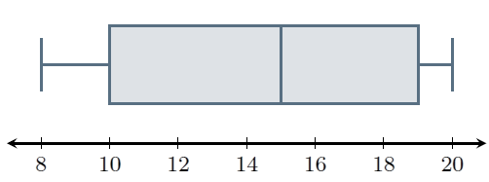

8

- What does the number 24 represent on the box plot shown?
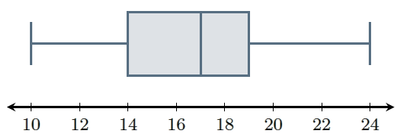
The maximum

- What is the range of the data set provided?
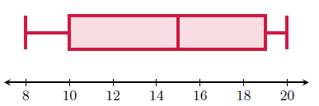
12

